**Sprint 1 - Endurance Design Document**

**March 24, 2021**

Armand Valentino, Kristina Good

**Table of Contents**

**1.** **EXECUTIVE SUMMARY**

1.1 Project Overview

1.2 Purpose and Scope of this Specification

**2.** **PRODUCT/SERVICE DESCRIPTION**

2.1 Product Context

2.2 User Characteristics

2.3 Assumptions

2.4 Constraints

2.5 Dependencies

**3.** **REQUIREMENTS**

3.1 Functional Requirements

3.2 Security

*3.2.1* *Protection*

*3.2.2* *Authorization and Authentication*

3.3 Portability

**4.** **REQUIREMENTS CONFIRMATION/STAKEHOLDER SIGN-OFF**

**5.** **SYSTEM DESIGN**

5.1 Algorithm

5.2 System Flow

5.3 Software

5.4 Hardware

5.5 Test Plan

5.6 Task List/Gantt Chart

5.7 Staffing Plan

# 1. Executive Summary

## ***1.1*** ***Project Overview***

The goal of this project was to create a program that would make a Sphero SPRK robot complete 1 lap of a rectangular course.

## ***1.2*** ***Purpose and Scope of this Specification***

This project is to show that our team can create a program that shows how steady this robot can follow a course. This is only part 1 of the final project. IT also shows how we can work as a team.

# 2. Product/Service Description

Many general factors and considerations must be taken into account when talking about this program. Steps will be taken to ensure a smooth operation.

## ***2.1*** ***Product Context***

This product runs independently with a user, and works in unison with the EDU programs on the computer.

## ***2.2*** ***User Characteristics***

Anyone can use this software and product, including younger people. For the most part they are also used for/by:

· Student/faculty/staff/other

· experience

· technical expertise

## ***2.3*** ***Assumptions***

Here describes any constraints or dependencies this design may need or encounter.

## ***2.4*** ***Constraints***

Some factors may limit the program from running properly with the product

·    Battery life/limits

·    Space, especially for courses

·    Access, management and security

·    Up-to-date software

·    Any unexpected glitch

## *2.5**Dependencies*

## ***2.5*** ***Dependencies***

Dependencies examples that will most definitely affect the program:

·    This program must need a secure Bluetooth connection between computer and product (Sphero)]

· Program needs a computer to run

# 3. Requirements

Many of the requirements listed within this section have been set in place form the computer science department here at Monmouth. These will be crucial in deciding whether our team successfully completed portions of this project.

## ***3.1*** ***Functional Requirements***

In the example below, the requirement numbering has a scheme - BR_LR_0## (BR for Business Requirement, LR for Labor Relations). For small projects simply BR-## would suffice. Keep in mind that if no prefix is used, the traceability matrix may be difficult to create (e.g., no differentiation between '02' as a business requirement vs. a test case)

The following table is an example format for requirements. Choose whatever format works best for your project.

For Example:

|  |  |  |  |  |  |
| --- | --- | --- | --- | --- | --- |
| **Req#** | **Requirement** | **Comments** | **Priority** | **Date Rvwd** | **SME Reviewed / Approved** |
| ENDUR_01 | Start with green light |  | Important | March 31st | Completed |
| ENDUR_02 | Speak “ready set go” |  | important | March 31st | Completed |
| ENDUR_03 | Follow the rectangle course |  | important | March 31st | Completed |
| ENDUR_04 | Stop at the same starting point |  | important | March 31st | Completed |
| ENDUR_05 | Speak “I am done” and have a red light |  | important | March 31st | Completed |

## ***3.2*** ***Security***

### **3.2.1** **Protection**

Certain factors must be ensured before the robot performs its activities. For example:

* flat surface
* no obstruction or obstacles (Sprint1)

### **3.2.2** **Authorization and Authentication**

Our team and progress will be overlooked by Professor Gil Eckert

## ***3.3*** ***Portability***

The Sphero company offers many products, including the SPRK. Our program can run on any SPRK device. Furthermore,

* Sphero SPRK can be operated anywhere, so long as the Sphero EDU program is running on a computer or laptop capable

# 4. Requirements Confirmation/Stakeholder sign-off

|  |  |  |
| --- | --- | --- |
| **Meeting Date** | **Attendees** | **Comments** |
| 03/24/2021 | Armand Valentno, Krstina Good | Completed part of Sprint 1 Project |

# 5. System Design

## ***5.1*** ***Algorithm***

The algorithm for Sprint 1 must be followed in some way to the following:

* Robot has to light up
* Robot has to speak
* Code for robot must follow a rectangle diagram.
* Robot must stop at the same point it started
* Robot should change light again
* Robot speaks again

## ***5.2*** ***System Flow***

Below is the system flow chart mapping out what our block code for Sprint 1 should look like:

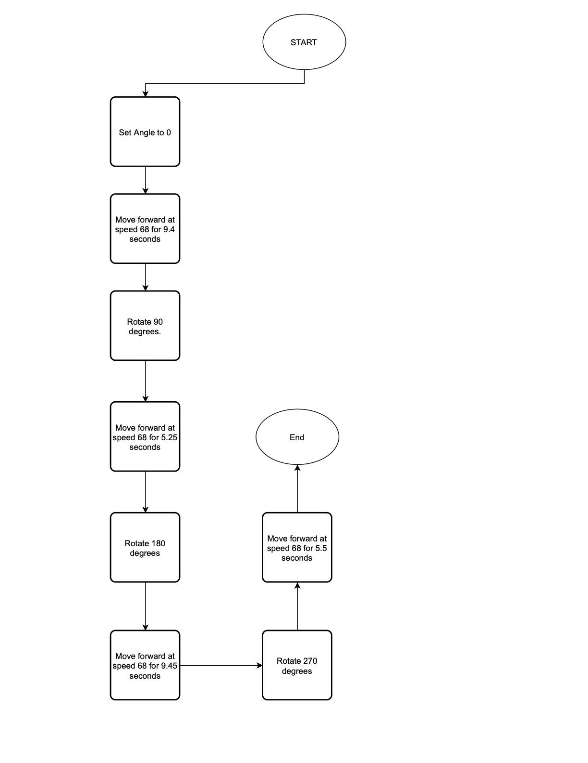

## The actual block coding program that was created and used on the robot is below, along with the sensor data showing the completion of 1 rectangular lap around the Endurance sprint court:

## ***5.3*** ***Software***

The software used to create and run this program is called Sphero EDU. Within the application, block coding is an option to create programs for the Sphero SPRK robot, which is what our team used.

## ***5.4*** ***Hardware***

Our team used a MacBook to test our product and its coding design.

## ***5.5*** ***Test Plan***

|  |  |  |  |  |  |
| --- | --- | --- | --- | --- | --- |
| **Reason for Test Case** | **Test Date** | **Expected Output** | **Observed Output** | **Staff Name** | **Pass/Fail** |
| First long straight (running 10 seconds) | 3/24 | Reach first end point | Overshot the endpoint | Kristina, Armand | Fail |
| First long straight (shortened running time) | 3/24 | Reach the first end point, and rotate for second leg. | Stopped right at the first end point to turn. | Kristina, Armand | Pass |
| First short straight (running 5 seconds) | 3/24 | Reach the second end point, and rotate for third leg. | Stopped too short of the second end point | Kristina, Armand | Fail |
| First Short straight (shortened running time) | 3/24 | Reach the second end point, and rotate for the third leg. | Stopped at the second end point, ready to turn. | Kristina, Armand | Pass |
| Second long straight & second short straight | 3/24 | Complete the third and fourth legs of the circuit using the same running times as first long, first short | Did not exactly follow the second half of the course correctly | Kristina, Armand | Fail |

## ***5.6*** ***Task List/Gantt Chart***

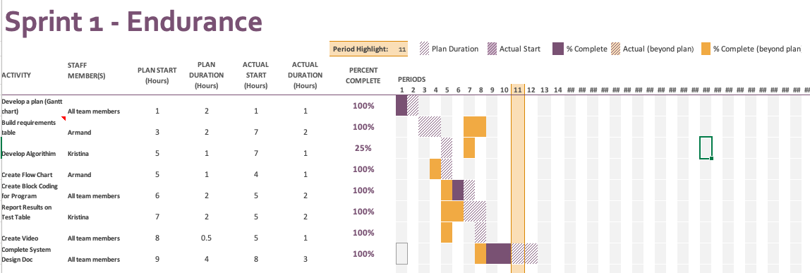

## ***5.7*** ***Staffing Plan***

Below lists a table of contributors to the project, and what roles and responsibility

|  |  |  |  |
| --- | --- | --- | --- |
| Name | Role | Responsibility | Reports To |
| Kristina Good | Coder/contributor | Gantt Chart, Develop algorithm, videographer, completing system design | Professor Gil Eckert |
| Armand Valentino | Coder/coder contributor | Gantt Chart, Create code and flowchart, completing system design | Professor Gil Eckert |